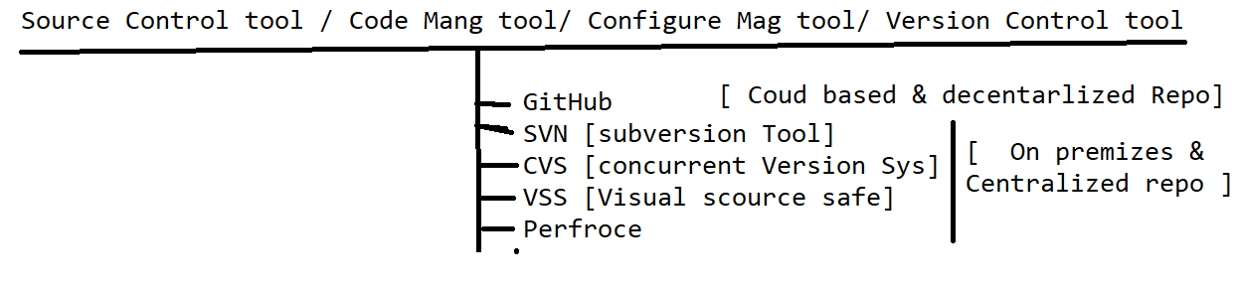

**What is Github**

It’s a distributed cloud decentralized repository where we can maintain our sourceCode / Automation Framwork / CRS doc /build of the application in one place

There are 2 Software in GitRepository

1. Git HUB : Cloud based repository(software) , which is used to maintain the source code ,create an account[https://github.com] in order to use it [no need to install]
2. Git [Git client] : it’s a software should installed in client machine , which is used to communicate to GITHUB
3. EG : Git client Software EGit , GitDeskTop , GitBash

**Advantages of GitHub Cloud**

1. Since its cloud based repository, no need have maintenance team to maintain the Software / HardWare
2. Cloud means pay rent for what you use
3. Cloud software always access via internet
4. Cloud System / server physically not present within the Organization, but present virtually
5. Initial investment is not required for Software/ Physical location
6. Scale UP / Scale Down is easy
7. File Share between the team members is easier
8. It provides remote access, it means anywhere contributors can access via internet
9. Provide History for changes made by users & backup facility
10. GitHub also provide platform to review [pull request] the Code of Automaton test scripts
11. GitHub Also handle the conflict’s
12. Jenkins Always get the latest framework from the Git for batch Execution

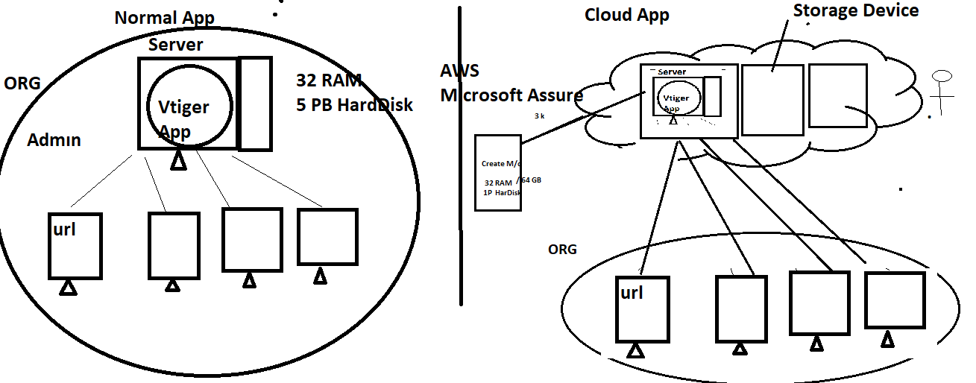

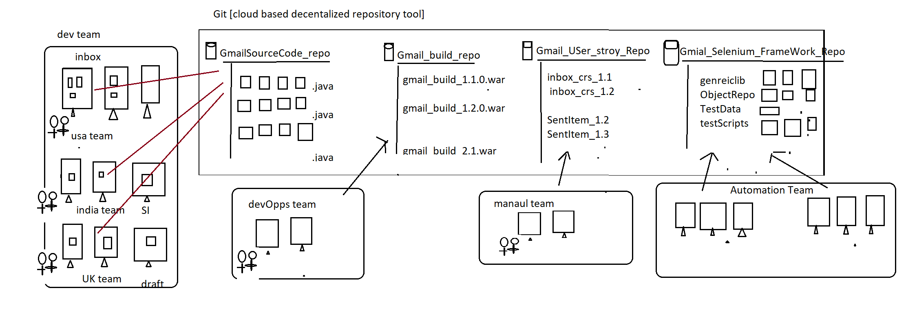

Developer Usage of Git : used to maintain the Source of the Application in one place

Automation Usage of Git : used to maintain the entire Automation framework in one place

DevOps Usage of Git : used to maintain the multiple application build version(like .exe, .war , .tar , .jar etc) in one place

Manual team Usage of Git : used to maintain the entire CRS / use case of the application

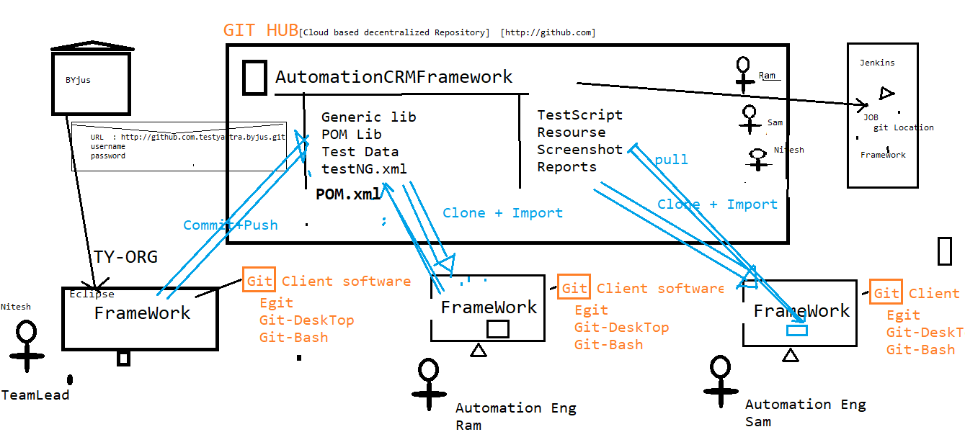

**Git Architecture**

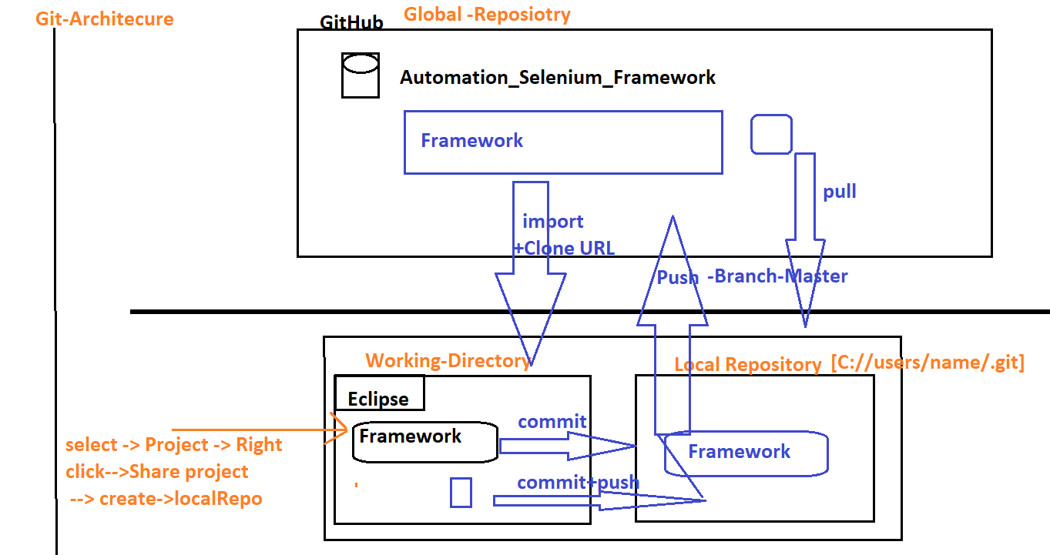

**Why Git is Decentralized Repository?**

Git is Decentralized Repository because, in Git before pushing any Code to git Hub, we have to commit the code to local repository first, make sure code is working in Local Repository then push Code to GITHUB(Global Repo)

* There are Three stages in Git , start with “Working Diretory”🡺Local Repo🡺Global Repo

**What is Git Conflicts**

When two or more engineers modified the same file , when Eng-1 one push the file to GitHub will not get any conflicts , but Eng-2 try to push the same file to GitHub , will get git

Conflicts (because that file already modified by Eng-1)

Solution: Before push any file to GitHub, we should mandatorily Pull the Project & select merge option , then[eclipse automatically merge the Code with comments]& remove comments manually & analyse the code then push it

**What is Pull Request ?**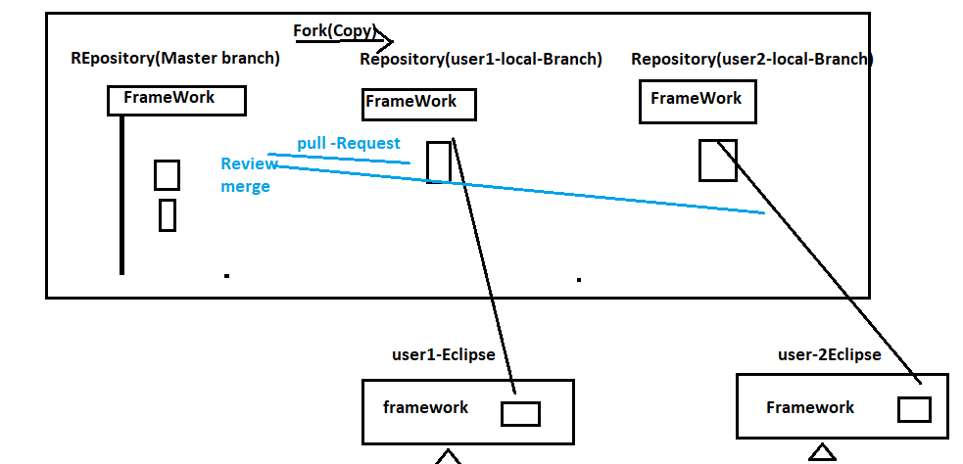

Whenever user made changes in the Programs , some Organization will not have access to push your changes to Master-Branch , in such case we supposed to create a local branch using “fork” option , than push the changes to local branch & than create “Pull Request” to Team lead asking for “REVIEW & MERGE” my program to master branch.

